Elton, Gruber, Brown, and Goetzmann
Modern Portfolio Theory and Investment Analysis, 9th Edition
Solutions to Text Problems: Chapter 12

Chapter 12: Problem 1

Equation (12.2) in the text can be used to answer this question:

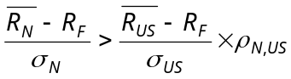

As is explained in the text, if the above inequality holds, then the foreign investment will be attractive to a U.S. investor. 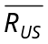 and 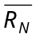 for the foreign countries are given in the problem's table. From the tables in the text, we have:

σ_{N} ρ_{N,US}

Australia 23.38 0.86
France 23.44 0.90
Japan 17.16 0.61
U.K. 18.32 0.90

Also, from the text tables, σ_{US} = 16.19. Given that R_{F} = 6%, we have:

Australia 0.342 0.478
France 0.427 0.500
Japan 0.466 0.339
U.K. 0.491 0.500

For Japan the above inequality holds, so a U.S. investor should consider those foreign markets as attractive investments; for Australia, France, and the U.K. the above inequality does not hold, so a U.S. investor should not consider those foreign markets as attractive investments.

Chapter 12: Problem 2

In the text, the return due to exchange-rate changes (R_{X}) is shown to be equal to fx_{t}/fx_{t-1} - 1, where fx_{t} is the foreign exchange rate at time t expressed in terms of the investor's home currency per unit of foreign currency. Let fx_{t} be the exchange rate expressed in terms of dollars and fx*_{t} be the exchange rate expressed in terms of pounds. These two rates are simply reciprocals, i.e., fx*_{t} = 1/fx_{t}. So from the table in the problem we have:

Period |  |  | (1 + R_{X})  (for US investor) | (1 + R*_{X})  (for UK investor)
 | 1 |  | 2.5/3 = 0.833 | 3/2.5 = 1.200
 | 2 |  | 2.5/2.5 = 1.000 | 2.5/2.5 = 1.000
 | 3 |  | 2/2.5 = 0.800 | 2.5/2 = 1.250
 | 4 |  | 1.5/2 = 0.750 | 2/1.5 = 1.333
 | 5 |  | 2.5/1.5 = 1.667 | 1.5/2.5 = 0.600

The total return to a U.S. investor from a U.K. investment is (1 + R_{X})(1 + R_{UK}) − 1; the total return to a U.K. investor from a U.S. investment is(1 + R*_{X})(1 + R_{US}) − 1. So:

Return to U.S. Investor
Period |  |  | From U.S.  Investment | From U.K. Investment
 | 1 |  | 10% | (0.833)(1.05) | − 1 | = | −12.5%
 | 2 |  | 15% | (1)(0.95) | − 1 | = | − 5.0%
 | 3 |  | −5% | (0.8)(1.15) | − 1 | = | − 8.0%
 | 4 |  | 12% | (0.75)(1.08) | − 1 | = | −19.0%
 | 5 |  | 6% | (1.667)(1.1) | − 1 | = | 83.3%
Average |  |  | 7.6% | 7.76%

Return to U.K. Investor
Period |  |  | From U.K.  Investment |  |  | From U.S. Investment
 | 1 |  |  | 5% |  | (1.2)(1.1) | − 1 | = | 32.0%
 | 2 |  |  | −5% |  | (1)(1.15) | − 1 | = | 15.0%
 | 3 |  |  | 15% |  | (1.25)(0.95) | − 1 | = | 18.75%
 | 4 |  |  | 8% |  | (1.333)(1.12) | − 1 | = | 49.3%
 | 5 |  |  | 10% |  | (0.6)(1.06) | − 1 | = | −36.4%
Average |  |  |  | 6.6% |  | 15.73%

Chapter 12: Problem 3

Using the data and averages from Problem 3 we have:

For U.S. Investor

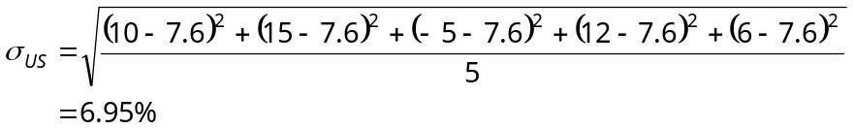

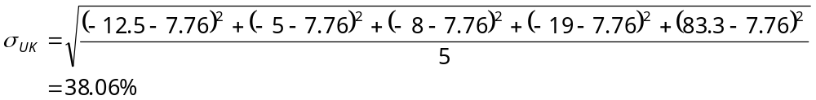

For U.K. Investor

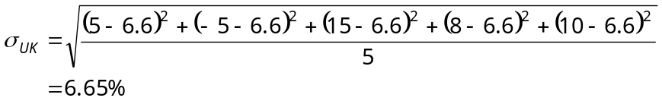

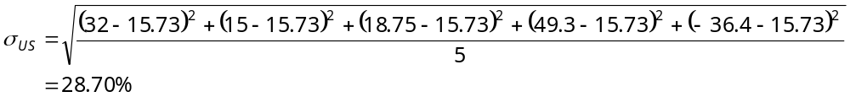

Chapter 12: Problem 4

This problem is essentially the same as Problem 3, except that the exchange rate is given in indirect (yen/$) terms rather than direct ($/yen) terms. From the table in the problem we have:

Period |  |  | (1 + R_{X})  (for US investor) | (1 + R*_{X})  (for Japanese investor)
 | 1 |  | 200/180 = 1.111 | 180/200 = 0.900
 | 2 |  | 180/190 = 0.947 | 190/180 = 1.056
 | 3 |  | 190/150 = 1.267 | 150/190 = 0.789
 | 4 |  | 150/170 = 0.882 | 170/150 = 1.133
 | 5 |  | 170/180 = 0.944 | 180/170 = 1.059

The total return to a U.S. investor from a Japan investment is (1 + R_{X})(1 + R_{J}) − 1; the total return to a Japanese investor from a U.S. investment is(1 + R*_{X})(1 + R_{US}) − 1. So:

Return to U.S. Investor
Period |  |  | From U.S.  Investment |  |  | From Japan Investment
 | 1 |  |  | 12% |  | (1.111)(1.18) | − 1 | = | 31.10%
 | 2 |  |  | 15% |  | (0.947)(1.12) | − 1 | = | 6.06%
 | 3 |  |  | 5% |  | (1.267)(1.1) | − 1 | = | 39.37%
 | 4 |  |  | 10% |  | (0.882)(1.12) | − 1 | = | −1.22%
 | 5 |  |  | 6% |  | (0.944)(1.07) | − 1 | = | 1.01%
Average |  |  |  | 9.6% |  | 15.26%

Return to Japanese Investor
Period |  |  | From Japan  Investment |  |  | From U.S. Investment
 | 1 |  |  | 18% |  | (0.9)(1.12) | − 1 | = | 0.80%
 | 2 |  |  | 12% |  | (1.056)(1.15) | − 1 | = | 21.44%
 | 3 |  |  | 10% |  | (0.789)(1.05) | − 1 | = | −17.16%
 | 4 |  |  | 12% |  | (1.133)(1.1) | − 1 | = | 24.63%
 | 5 |  |  | 7% |  | (1.059)(1.06) | − 1 | = | 12.25%
Average |  |  |  | 11.8% |  | 8.39%

Chapter 12: Problem 6

The answers to this problem are found in the same way as those to Problem 4.

For the U.S. investor: σ_{US} = 3.72%; σ_{J} = 16.68%

For the Japanese investor: σ_{J} = 3.6%; σ_{US} = 15.227%

Chapter 12: Problem 7

Use the formula for the sample correlation coefficient ρ with five observations:

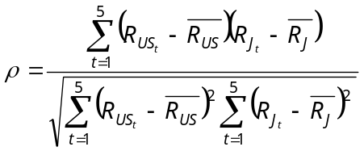

For the U.S. investor, ρ = −0.251.

For the Japanese investor, ρ = −0.050.

